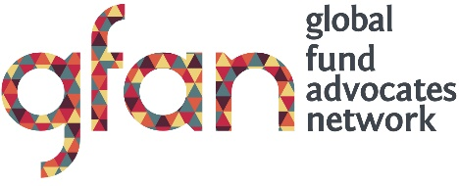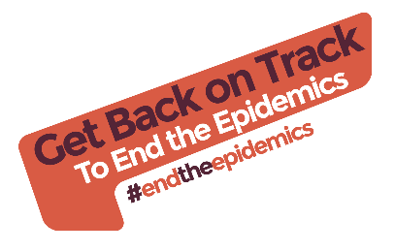

Sample Social Media Posts for the Get back on Track to End the Epidemics Campaign:
In Advance and during the IAS Conference 23-27 July 2018:
- We need to get Back on Track to #EndtheEpidemics of AIDS, TB and Malaria. Our call to action to #fundthefund will be launched at #AIDS2018.
- We need to get Back on Track to #EndtheEpidemics of AIDS, TB and Malaria. (Your organization) supports the @GFadvocates call to action to #fundthefund !
- Add your voice, the time for action is now. #EndtheEpidemics of AIDS, TB and Malaria #fundthefund
- We need to get Back on Track to #EndtheEpidemics of AIDS, Malaria and TB. Are you at #AIDS2018? Stop by the @GFadvocates booth #526 to learn more.

After the GFAN Press conference on 25 July 2018:
- We need to get Back on Track to #EndtheEpidemics of AIDS, TB and Malaria. Our call to action to #fundthefund is here: www.globalfundadvocatesnetwork.org/campaign/get-back-on-track
- Add your voice, the time for action is now #EndtheEpidemics of AIDS, TB and Malaria. www.globalfundadvocatesnetwork.org/campaign/get-back-on-track #fundthefund
- To Get Back on Track to #EndtheEpidemics the Global Fund will need to raise between US$16.8 billion and US$18 billion at the 6th Replenishment in 2019 to meet its share of the US$46 billion needed annually to end the epidemics. #fundthefund
- We need to get Back on Track to #EndtheEpidemics of AIDS, TB and Malaria. (Your organization) supports the @GFadvocates call to action to #fundthefund! www.globalfundadvocatesnetwork.org/campaign/get-back-on-track

Longer Sample Posts for Facebook:

If the world only maintains current levels of investments and programming against the three epidemics, global targets for 2025 and 2030 will be unattainable. We need to #fundthefund to Get Back on Track and #EndtheEpidemics. For the full report visit: http://www.globalfundadvocatesnetwork.org/campaign/get-back-on-track

Significant increases in international funding are needed, immediately, if the global goal to end the three epidemics is to be met. GFAN in its Back on Track Report is calling for increased investments in the Global Fund which will need to raise between US$16.8 billion and US$18 billion at the 6th Replenishment in 2019 #EndtheEpidemics
http://www.globalfundadvocatesnetwork.org/campaign/get-back-on-track

